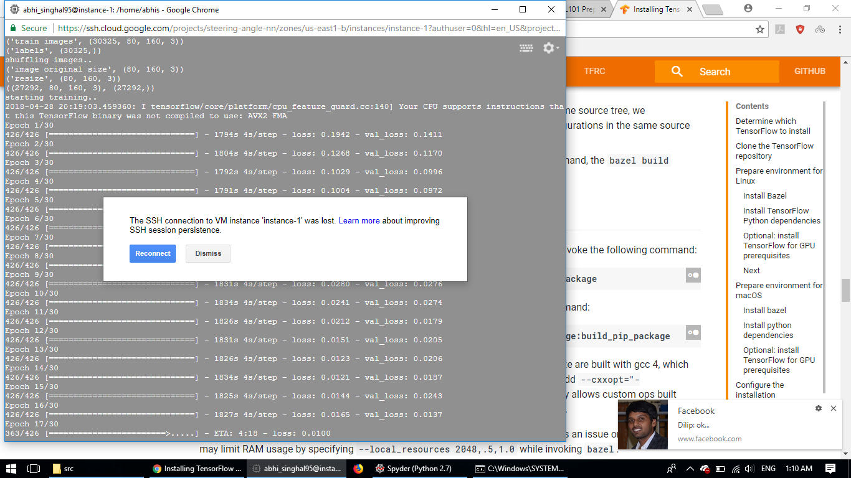

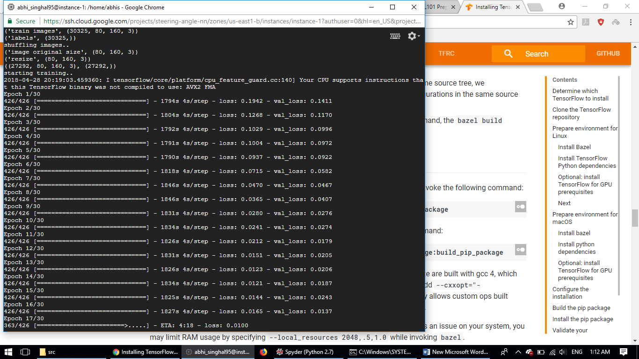

Vanilla STA

Epoch 1/10426/426 [==============================] - 1777s 4s/step - loss: 0.0653 - val_loss: 0.0588 Epoch 2/10 426/426 [==============================] - 1780s 4s/step - loss: 0.0405 - val_loss: 0.0397 Epoch 3/10 426/426 [==============================] - 1778s 4s/step - loss: 0.0282 - val_loss: 0.0341 Epoch 4/10 426/426 [==============================] - 1785s 4s/step - loss: 0.0200 - val_loss: 0.0327 Epoch 5/10 426/426 [==============================] - 1786s 4s/step - loss: 0.0166 - val_loss: 0.0241 Epoch 6/10 426/426 [==============================] - 1793s 4s/step - loss: 0.0134 - val_loss: 0.0197 Epoch 7/10 426/426 [==============================] - 1785s 4s/step - loss: 0.0124 - val_loss: 0.0295 Epoch 8/10 426/426 [==============================] - 1784s 4s/step - loss: 0.0137 - val_loss: 0.0163 Epoch 9/10 426/426 [==============================] - 1788s 4s/step - loss: 0.0110 - val_loss: 0.0155 Epoch 10/10 426/426 [==============================] - 1764s 4s/step - loss: 0.0097 - val_loss: 0.0127 _________________________________________________________________ Layer (type) Output Shape Param # ================================================================= batch_normalization_1 (Batch (None, 80, 160, 3) 12 _________________________________________________________________ Conv1 (Conv2D) (None, 76, 156, 24) 1824 _________________________________________________________________ Conv2 (Conv2D) (None, 72, 152, 36) 21636 _________________________________________________________________ max_pooling2d_1 (MaxPooling2 (None, 36, 76, 36) 0 _________________________________________________________________ Conv3 (Conv2D) (None, 32, 72, 48) 43248 _________________________________________________________________ dropout_1 (Dropout) (None, 32, 72, 48) 0 _________________________________________________________________ Conv4 (Conv2D) (None, 30, 70, 64) 27712 _________________________________________________________________ dropout_2 (Dropout) (None, 30, 70, 64) 0 _________________________________________________________________max_pooling2d_2 (MaxPooling2 (None, 15, 35, 64) 0 _________________________________________________________________Conv5 (Conv2D) (None, 13, 33, 64) 36928 _________________________________________________________________dropout_3 (Dropout) (None, 13, 33, 64) 0 _________________________________________________________________Conv6 (Conv2D) (None, 11, 31, 128) 73856 _________________________________________________________________dropout_4 (Dropout) (None, 11, 31, 128) 0 _________________________________________________________________max_pooling2d_3 (MaxPooling2 (None, 5, 15, 128) 0 _________________________________________________________________flatten_1 (Flatten) (None, 9600) 0 _________________________________________________________________dense_1 (Dense) (None, 1164) 11175564 _________________________________________________________________activation_1 (Activation) (None, 1164) 0 _________________________________________________________________dense_2 (Dense) (None, 100) 116500 _________________________________________________________________activation_2 (Activation) (None, 100) 0 _________________________________________________________________dense_3 (Dense) (None, 50) 5050 _________________________________________________________________activation_3 (Activation) (None, 50) 0 _________________________________________________________________dense_4 (Dense) (None, 10) 510 _________________________________________________________________activation_4 (Activation) (None, 10) 0 _________________________________________________________________dense_5 (Dense) (None, 1) 11 =================================================================Total params: 11,502,851Trainable params: 11,502,845Non-trainable params: 6_________________________________________________________________

training accuracy..

0.0779019790277

0.653524842445

validation accuracy..

0.0938397028303

0.647543686119

11-20

Epoch 1/10426/426 [==============================] - 1758s 4s/step - loss: 0.0097 - val_loss: 0.0102Epoch 2/10426/426 [==============================] - 1755s 4s/step - loss: 0.0086 - val_loss: 0.0079Epoch 3/10426/426 [==============================] - 1763s 4s/step - loss: 0.0070 - val_loss: 0.0088Epoch 4/10426/426 [==============================] - 1763s 4s/step - loss: 0.0092 - val_loss: 0.0189Epoch 5/10426/426 [==============================] - 1754s 4s/step - loss: 0.0124 - val_loss: 0.0084Epoch 6/10426/426 [==============================] - 1759s 4s/step - loss: 0.0066 - val_loss: 0.0070Epoch 7/10426/426 [==============================] - 1767s 4s/step - loss: 0.0053 - val_loss: 0.0080Epoch 8/10426/426 [==============================] - 1768s 4s/step - loss: 0.0066 - val_loss: 0.0080Epoch 9/10426/426 [==============================] - 1751s 4s/step - loss: 0.0051 - val_loss: 0.0082Epoch 10/10426/426 [==============================] - 1742s 4s/step - loss: 0.0066 - val_loss: 0.0256

training accuracy..

0.137966916901

0.419023889785

11-15

Epoch 1/5426/426 [==============================] - 1747s 4s/step - loss: 0.0103 - val_loss: 0.0134

Epoch 2/5426/426 [==============================] - 1754s 4s/step - loss: 0.0079 - val_loss: 0.0081

Epoch 3/5426/426 [==============================] - 1764s 4s/step - loss: 0.0082 - val_loss: 0.0103

Epoch 4/5 67/426 [==============================] - 1749s 4s/step - loss: 0.0087 - val_loss: 0.0101

Epoch 5/5426/426 [==============================] - 1745s 4s/step - loss: 0.0083 - val_loss: 0.0089

training accuracy..

0.0690621819147

0.71119742049

validation accuracy..

0.0757158849813

0.70161556215

|  |  |  |  |  |
| --- | --- | --- | --- | --- |
| Training method | epochs | Training rmse | Val rmse | Testing rmse |
| Vanilla steering- NVIDIA | 10 | 0.0779019790277 | 0.0938397028303 | 0.133360102313 |
| Vanilla steering- NVIDIA | 15 | 0.0690621819147 | 0.0757158849813 | 0.142470523841 |
| Vanilla steering- NVIDIA | 20 | 0.137966916901 |  | 0.156531051125 |
| Lane detection steering - NVIDIA |  |  |  |  |
| Vanilla steering - Baseline |  |  |  |  |
| Lane detection steering - Baseline |  |  |  |  |